- [ ] CH01-MU01 — System Overview Conceptual Diagram

- [ ] CH02-MU01 — Layer Separation Diagram

- [X] CH03-MU01 — Notes Sidebar Folder Layout

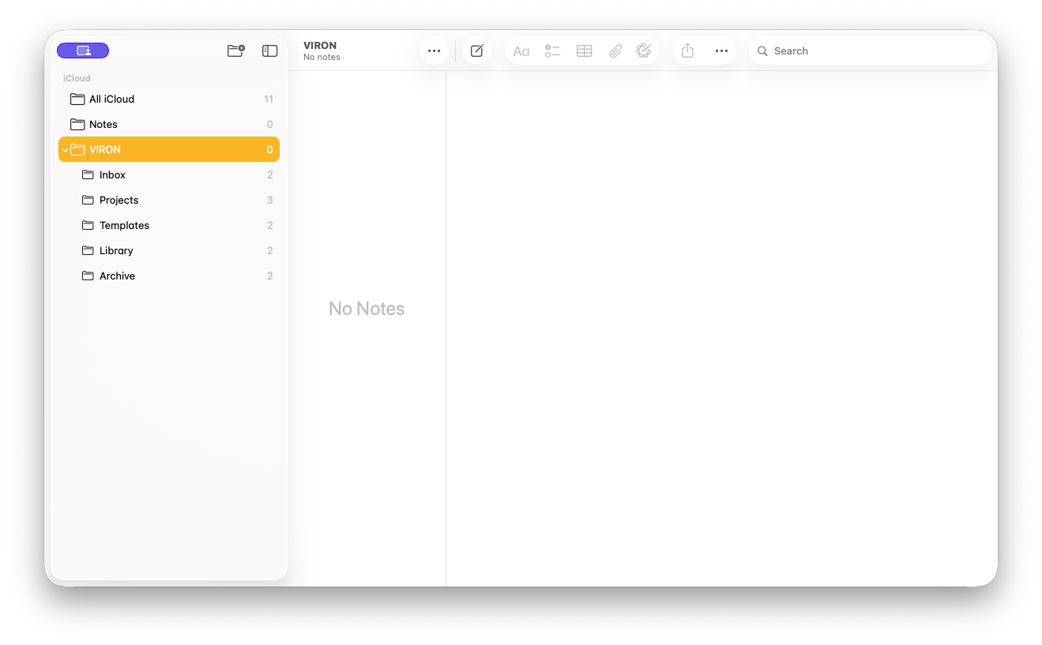

- [X] CH03-MU02 — Idea Inbox Note Structure

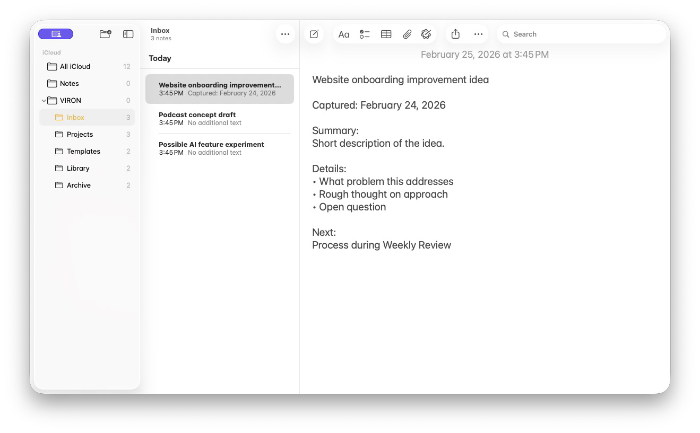

- [X] CH03-MU03 — Projects Folder with 3 Active Projects

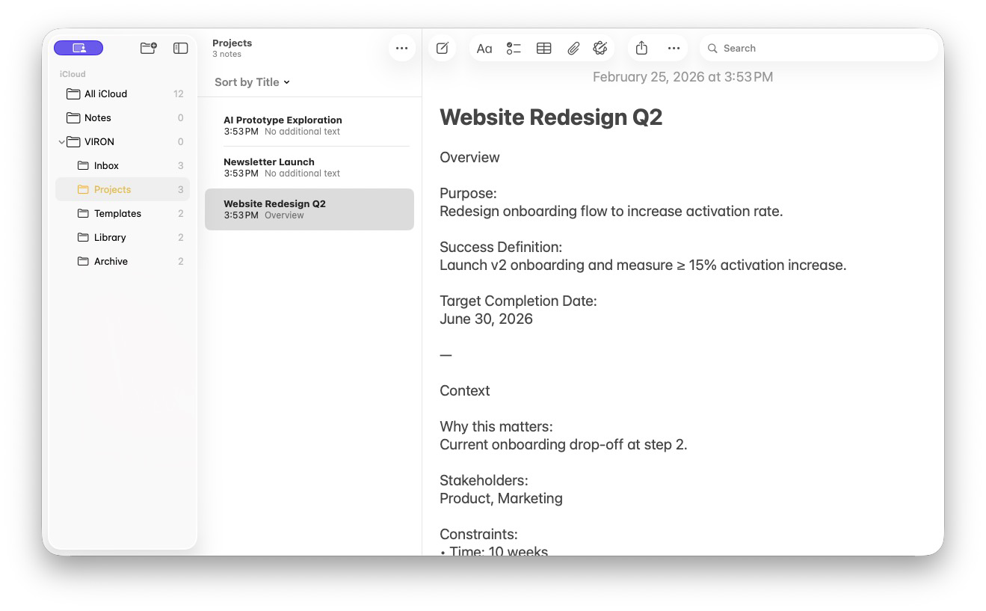

- [X] CH03-MU04 — Library Folder with Atomic Notes

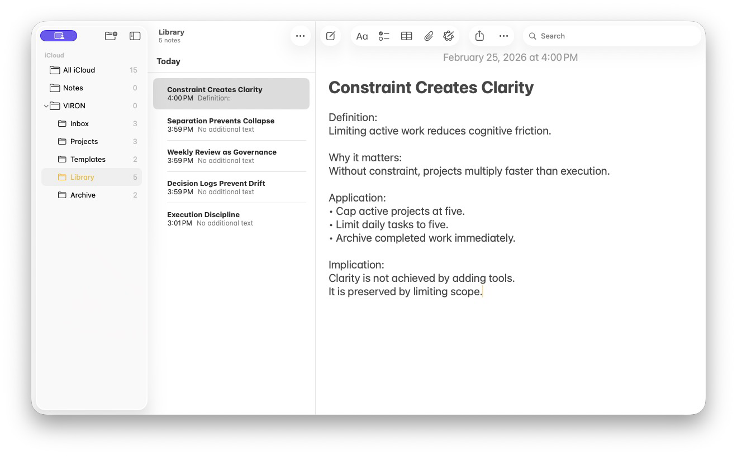

- [X] CH03-MU05 — Notes Settings Configuration

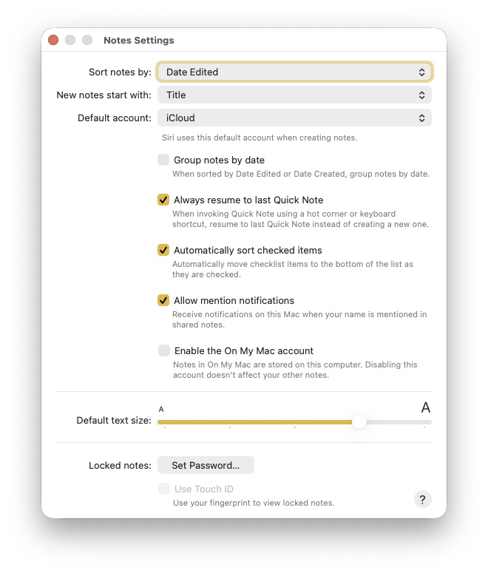

- [X] CH03-MU06 — Apple Intelligence ChatGPT Extension Enabled

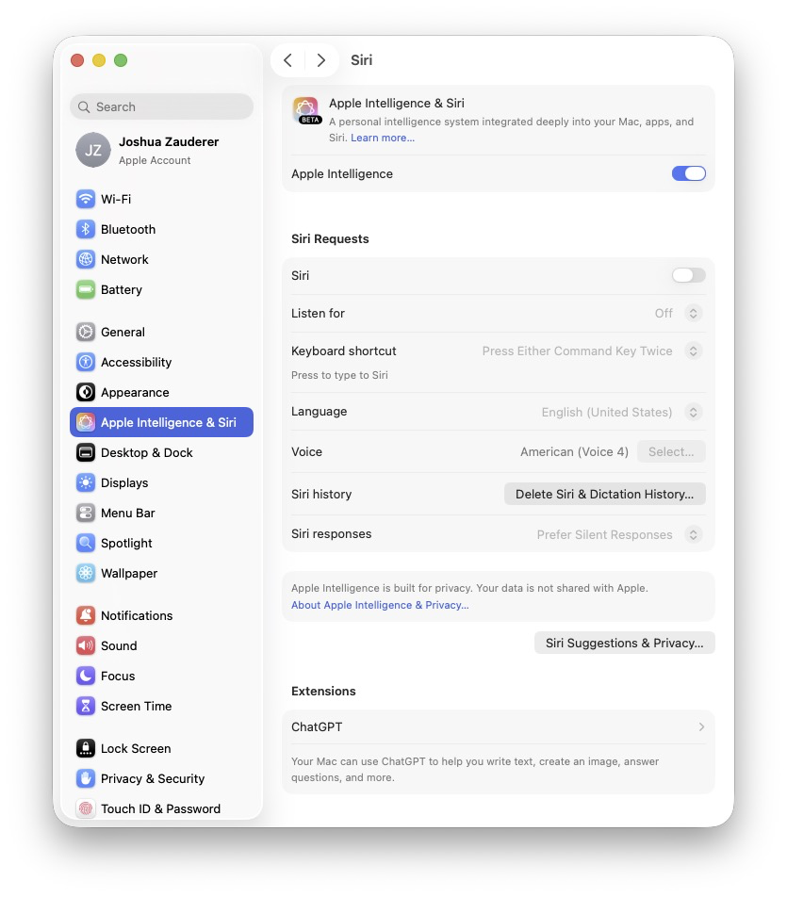

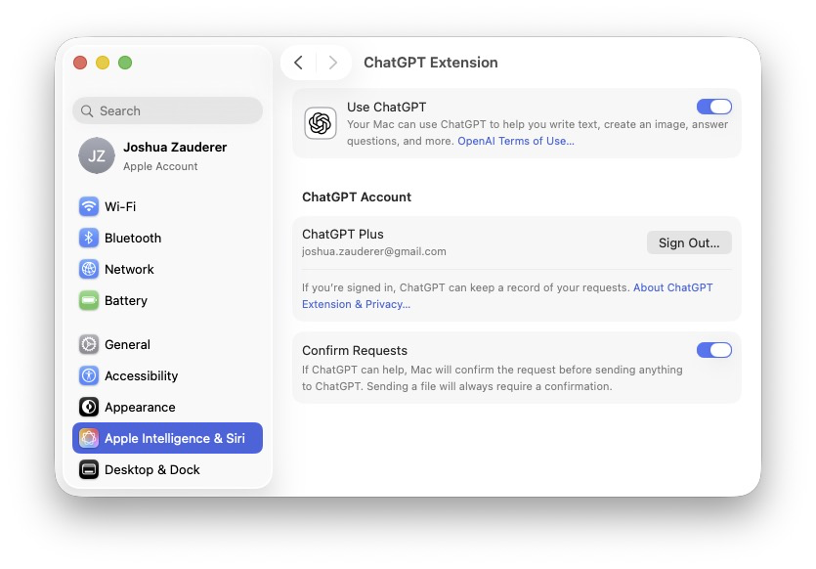

- [X] CH04-MU01 — Clean Reminders List

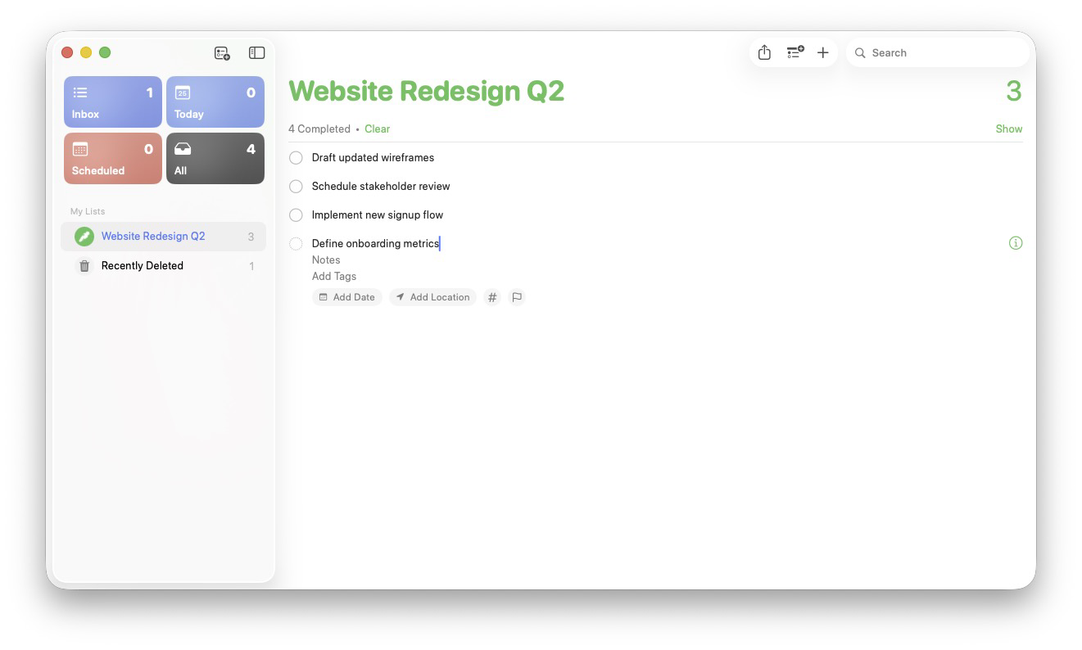

- [X] CH04-MU02 — Reminders Project-Specific Task View

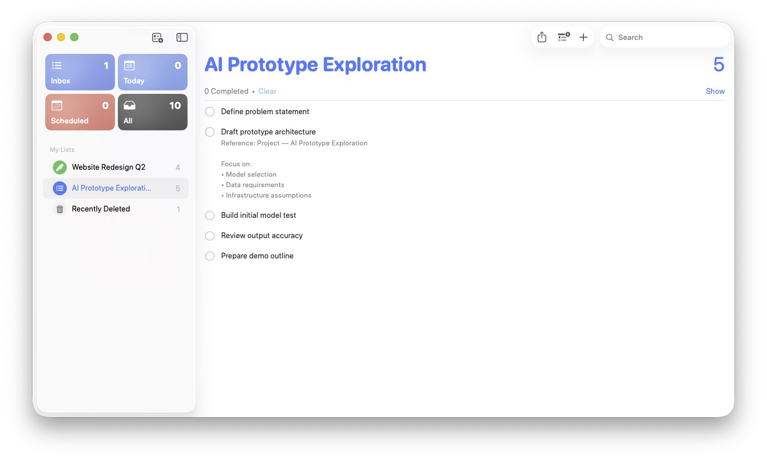

- [X] CH05-MU01 — Quick Capture Shortcut Flow

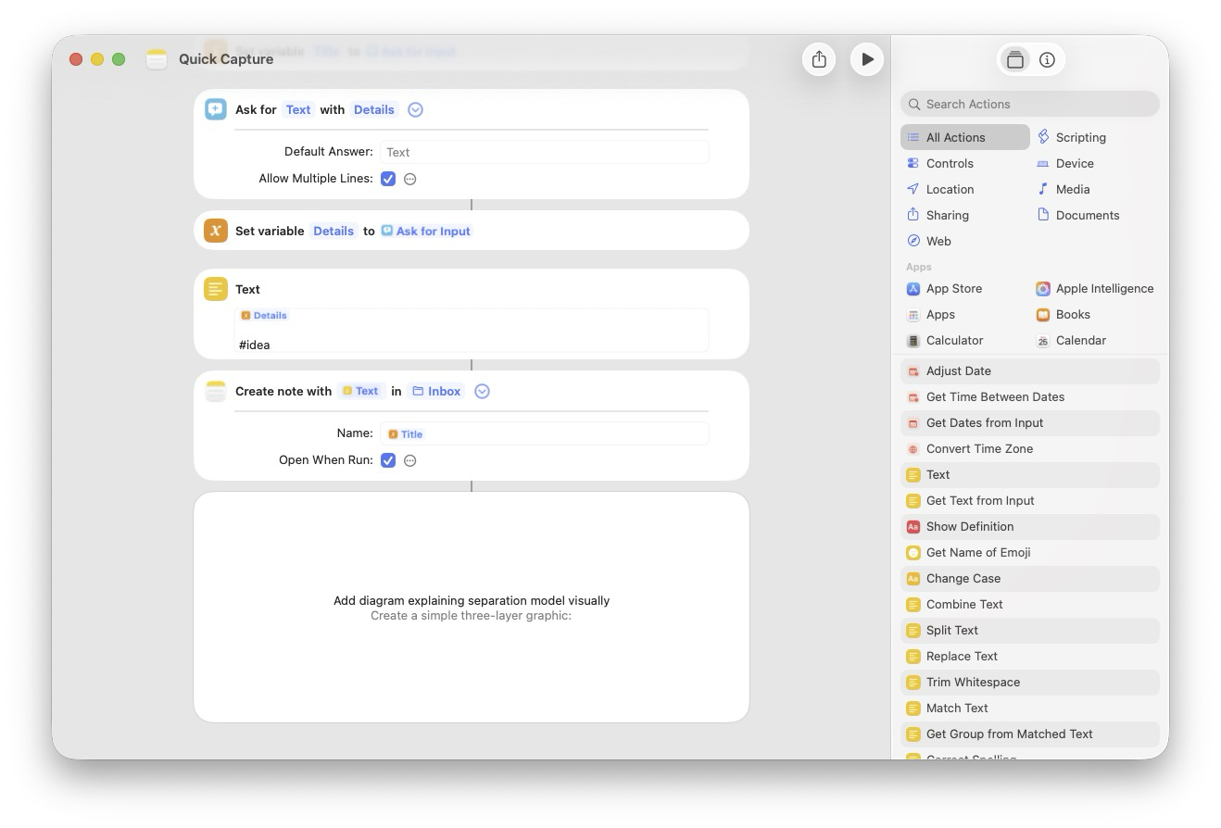

- [X] CH05-MU02 — Send to Reminders Shortcut

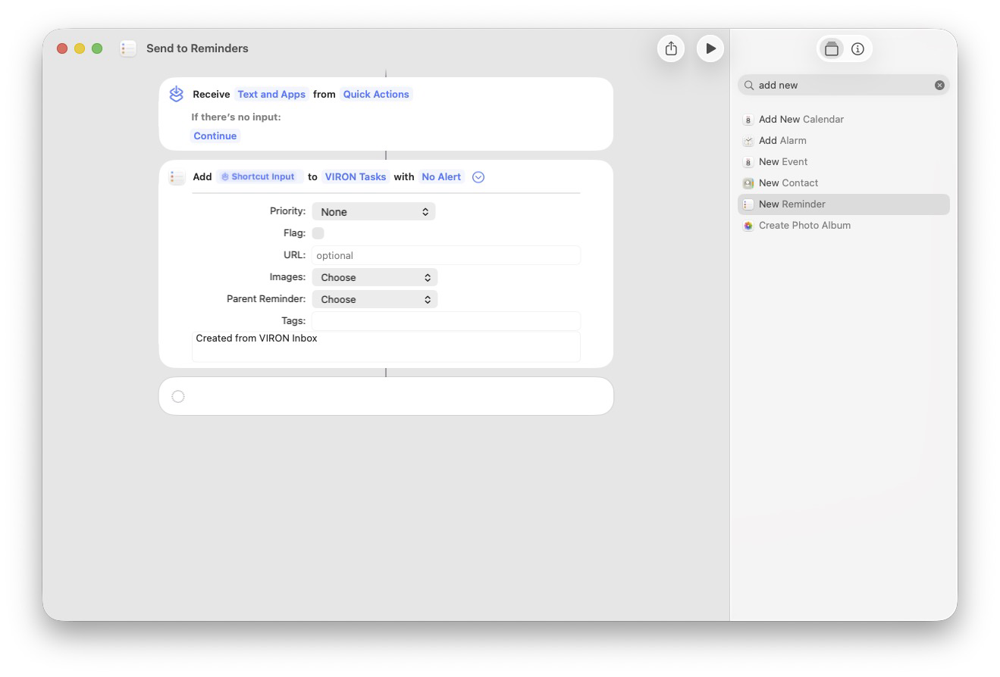

CH05-MU02 — Send to Reminders Shortcut

This shortcut converts a processed idea into an actionable task.
When reviewing items in the Inbox, highlight any text that represents a concrete action and run the Send to Reminders shortcut. The selected text becomes the title of a new reminder in the VIRON Tasks list.
Only items that require execution should be sent to Reminders. Everything else remains in Notes for reference, development, or archiving. This maintains a clear boundary between ideas and commitments.

- [ .] CH05-MU03 — Daily Planning Shortcut

- [ ] CH05-MU04 — Weekly Reset Shortcut

- [ ] CH05-MU05 — Shortcut Architecture Concept Diagram

- [ ] CH06-MU01 — Weekly Review Structure Overview

- [ ] CH07-MU01 — Unified Architecture Diagram

- [ ] CH08-MU01 — Library Folder (Mature State)

- [ ] CH09-MU01 — Failure Mode Example

- [ ] CH13-MU01 — Maturity Model Diagram

- [ ] CH14-MU01 — Team Adaptation Diagram

- [ ] CH15-MU01 — 90-Day Roadmap
